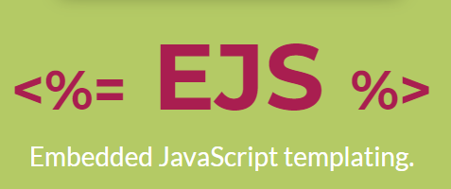  EJS Tutorial | A quick guide to the fundamentals of EJS templating

